|  |  |  |  |  |
| --- | --- | --- | --- | --- |
| MODEL | Accuracy | Loss | Val_accuracy | Val_loss |
| CNN | 0.9225 | 0.2451 | 0.9180 | 0.3196 |
| MOBILENETV2 | 0.9639 | 0.1203 | 0.9426 | 0.2491 |
| VGG19 | 0.8531 | 0.3978 | 0.8689 | 0.4033 |
|  |  |  |  |  |
|  |  |  |  |  |
|  |  |  |  |  |

**CNN:**

model.evaluate(test_data)

accuracy: 0.9329 - loss: 0.2451 [0.32776060700416565, 0.9114583134651184]

**Classification Report:**

**precision recall f1-score support**

**Crack 0.86 0.98 0.92 63**

**Pothole 0.97 0.85 0.91 46**

**Surface Erosion 0.93 0.89 0.91 83**

**accuracy 0.91 192**

**macro avg 0.92 0.91 0.91 192**

**weighted avg 0.92 0.91 0.91 192**

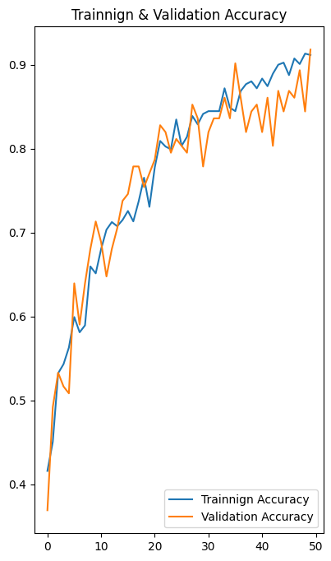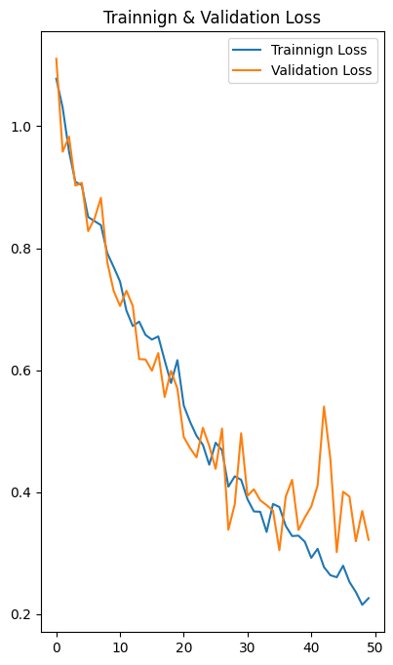

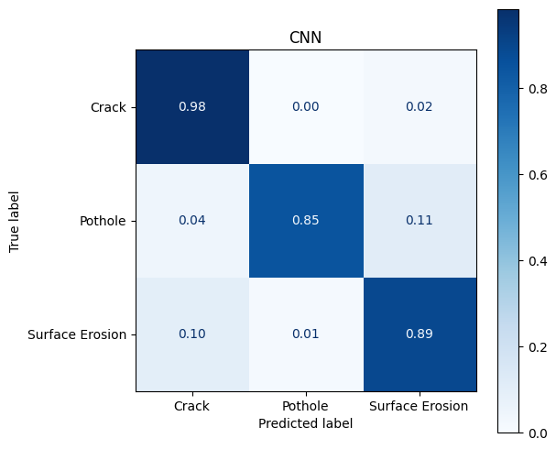

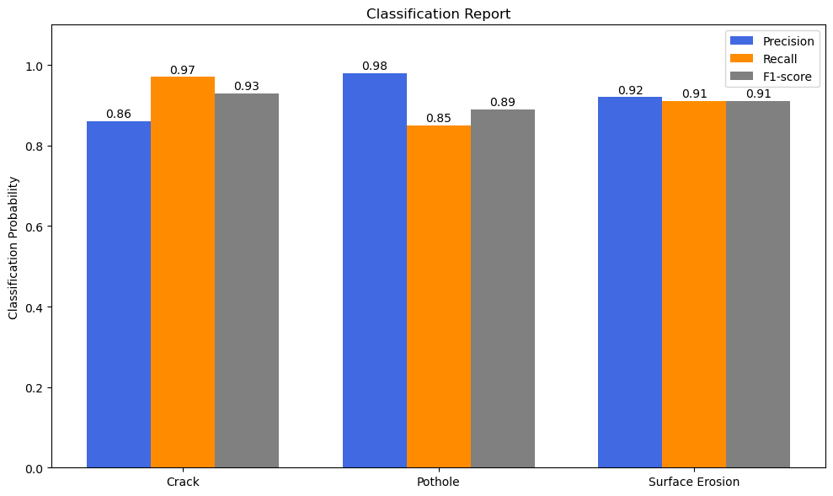

**MOBILENETVv2:**

**model.evaluate(test_data):**

**accuracy: 0.9557 - loss: 0.1447 [0.18042850494384766, 0.9479166865348816]**

**Classification Report:**

**precision recall f1-score support**

**Crack 0.97 0.95 0.96 65**

**Pothole 0.94 0.94 0.94 48**

**Surface Erosion 0.94 0.95 0.94 79**

**accuracy 0.95 192**

**macro avg 0.95 0.95 0.95 192**

**weighted avg 0.95 0.95 0.95 192**

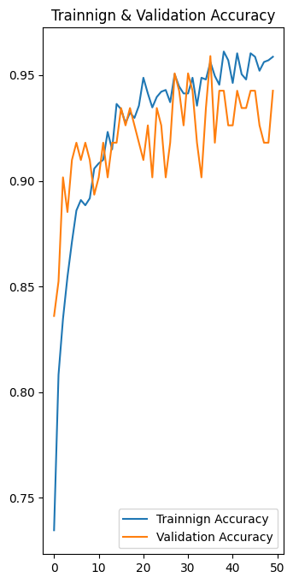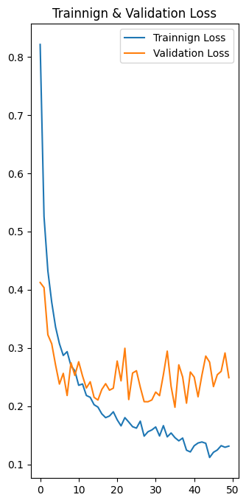

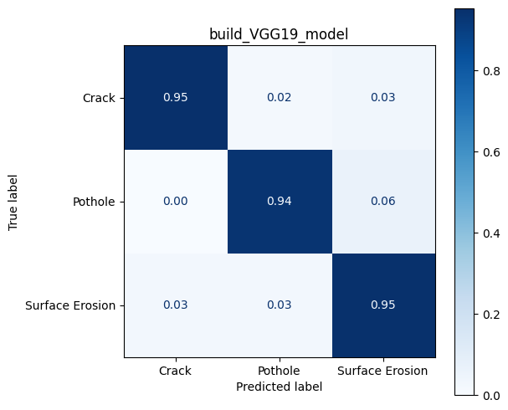

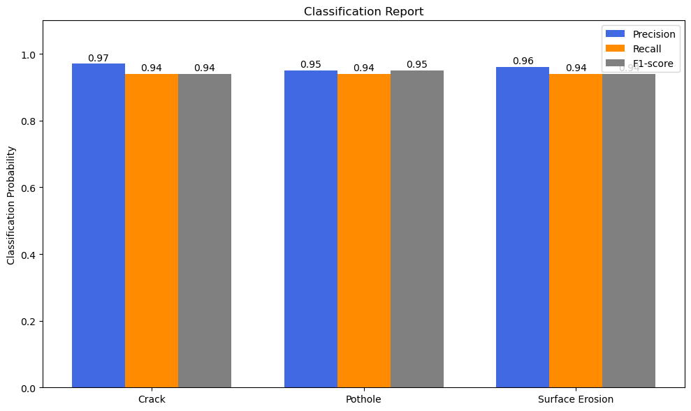

**VGG19:**

**model.evaluate(test_data):**

**accuracy: 0.8482 - loss: 0.4231 [0.4114433825016022, 0.8541666865348816]**

**Classification Report:**

**precision recall f1-score support**

**Crack 0.90 0.83 0.86 64**

**Pothole 0.88 0.78 0.82 45**

**Surface Erosion 0.82 0.92 0.86 83**

**accuracy 0.85 192**

**macro avg 0.86 0.84 0.85 192**

**weighted avg 0.86 0.85 0.85 192**

